**Github / IntelliJ Setup Instructions**

1. Install IntelliJ.

<https://www.jetbrains.com/idea/download/download-thanks.html?platform=windows&code=IIC>

1. Install Git.

<https://git-scm.com/downloads>

1. Open IntelliJ and click on the *Configure* icon toward the bottom of the window.



1. Click *Settings.*

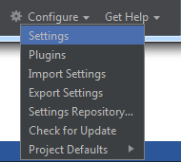

1. There are two different settings you will need to configure to be able to connect to our GitHub project.

Navigate to *Version Control -> Git.*

Direct IntelliJ to your git executable. Mine was located here: C:\Program Files\Git\bin\git.exe

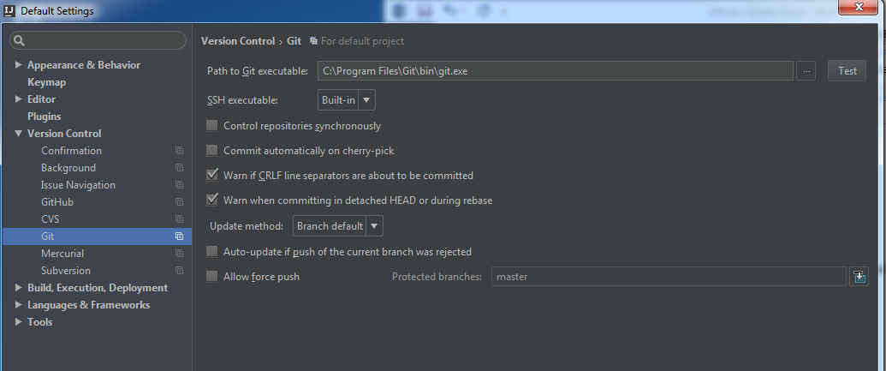

1. Navigate to *Version Control -> GitHub.*   
   Here we will tell IntelliJ the logon credentials for GitHub so we can connect to it within the IDE.

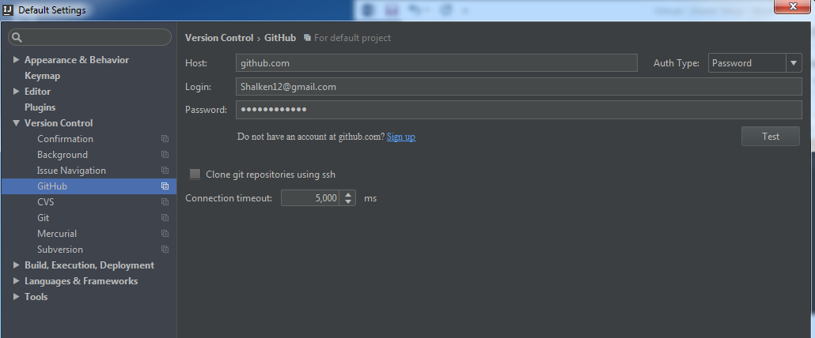

You can click the test button to ensure that your connection to GitHub is successful.

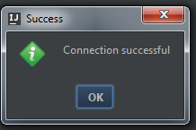

1. Hit *Apply* and *OK* at the bottom right.



1. Click the dropdown arrow to *Check out from Version Control* and click *Github.*

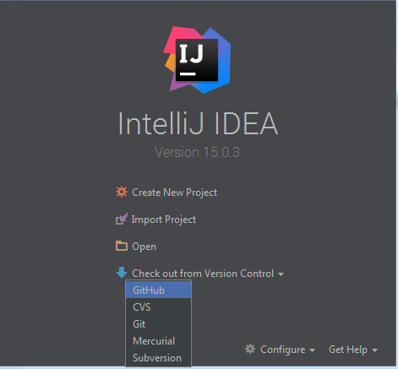

1. Clone the “Games” repository. If you click the dropdown it will show you all repositories you have access to.

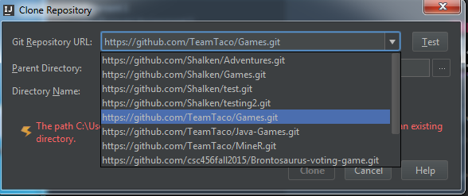

1. You can choose what directory you want to save the project and I would recommend that you save the Directory Name as “Games” because it can cause configuration issues with other people’s local copy, but it’s up to you. We can figure this out if it causes complications.

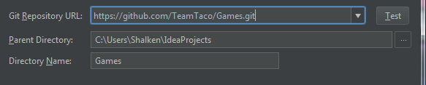

1. Click *Clone.*
2. Click *Yes.*

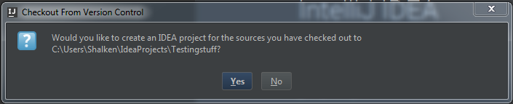

1. Click *Next.*

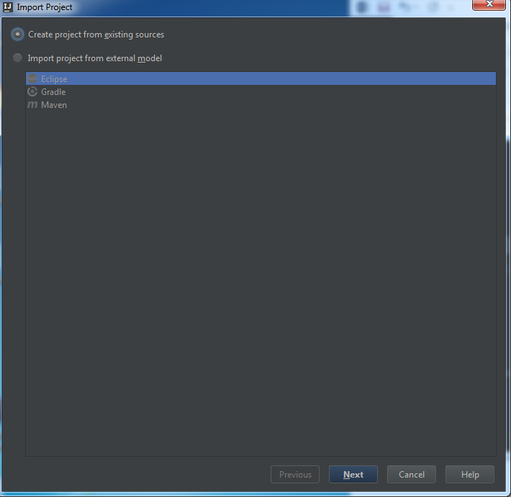

1. Name the project “Games” and click *Next.*

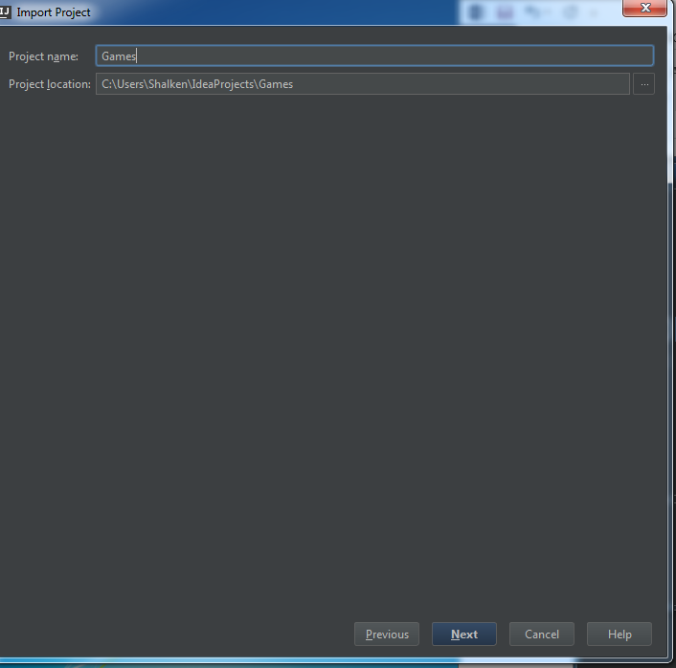

1. Click *Next.*

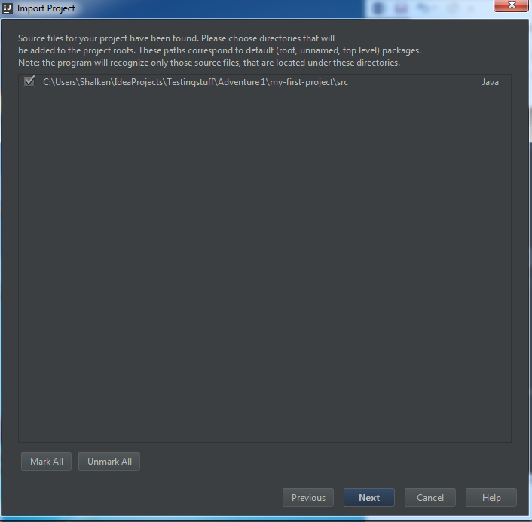

1. Click *Next.*

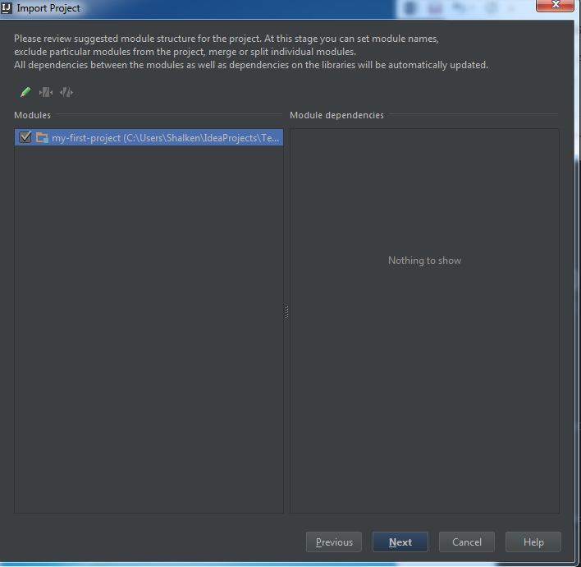

1. Select your SDK and click *Next.*

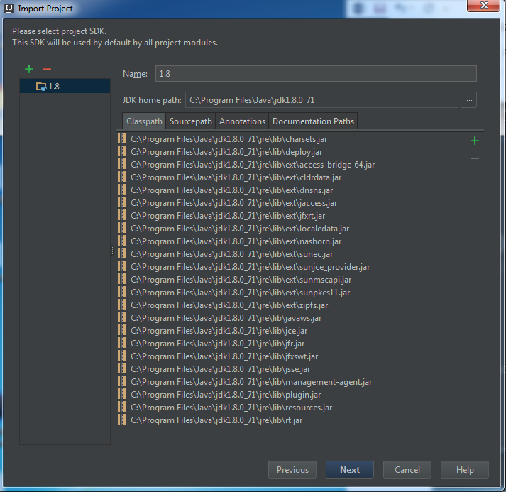

1. Click *Finish.*



1. Your project will now open. To checkout a certain branch navigate to *VCS -> Git -> Branches*

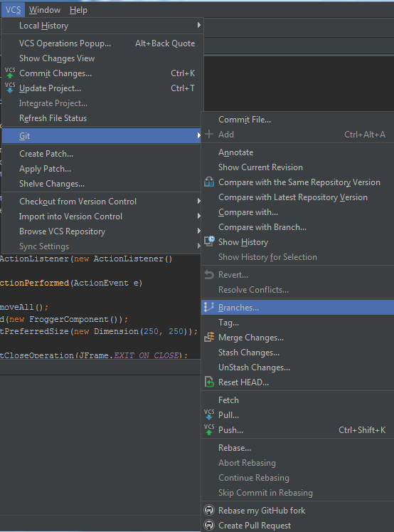

1. Checkout the development branch.

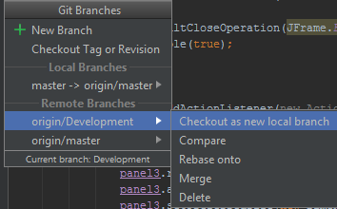

Now you should be able to push and pull to and from github via these two buttons: 

The first will pull information down from GitHub and the second will push to it.

